Patrick Harrington
Bachelor of Science in Computer Science, SNHU
CS 405: Secure Coding
Instructor: Aaron Demory
June 6, 2026
5-2 Activity: Encryption Coding
Application Console Output:
The screenshot below shows the program running successfully and creating the encrypted and decrypted data files using the required source-code filenames.
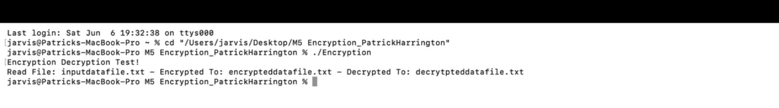
Brief Process Summary
XOR encryption: I completed the encrypt_decrypt method by looping through each character in the source string and XORing it with a character from the password key. I used i % key_length so the password repeats correctly when the file data is longer than the key.
File loading: I replaced the placeholder string in read_file with an ifstream and an ostringstream. This reads the full input data file into one string while preserving line breaks and spacing.
File saving: I implemented save_data_file using an ofstream. The method writes the required format: student name on line 1, the current date on line 2, the key on line 3, and the transformed data beginning on line 4.
Debugging and corrections: The main issues corrected were incomplete TODO sections, missing file input/output logic, and the XOR key-length problem. I tested by compiling the program, running it, confirming both output files were created, and checking that the decrypted data contains the original input content after the required three-line header.
Best practices used: The code uses clear variable names, inline comments near the completed logic, checks for file open failures, and binary file mode for reading and writing so encrypted control characters are preserved accurately.
Files Created
- Encryption.cpp - completed source code
- inputdatafile.txt - original input data file
- encrypteddatafile.txt - encrypted output file
- decrypteddatafile.txt - decrypted output file

